 Why Delta Tables? Here’s what sets them apart:   
• ACID transactions for reliable data updates   
• Time travel capabilities for easy data auditing   
• Schema evolution without disruptions   
• Optimized data skipping for faster queries   
• Native support for streaming and batch workloads   
• Simplified data management in Lakehouse architecture   
Unlock the potential of your data ecosystem—Delta Tables make it seamless.

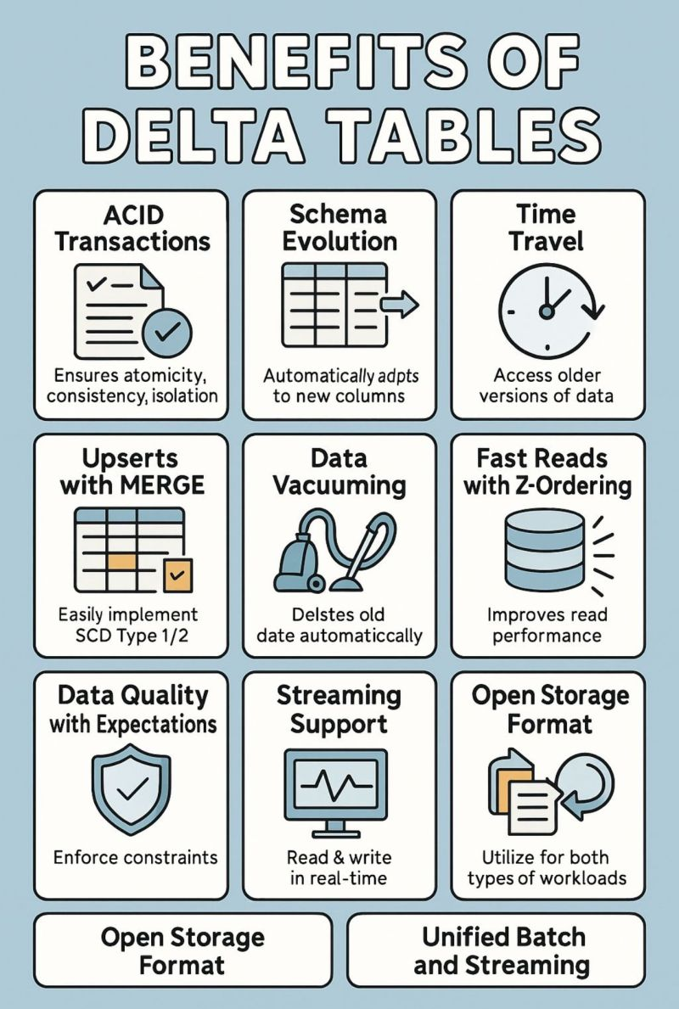

 Delta Lake ensures ACID guarantees and time travel  
🔹 Delta Tables unlock efficient upserts, optimization, and streaming  
🔹 Delta Live Tables (DLT) elevate your pipelines with automation, CDC, and built-in quality checks

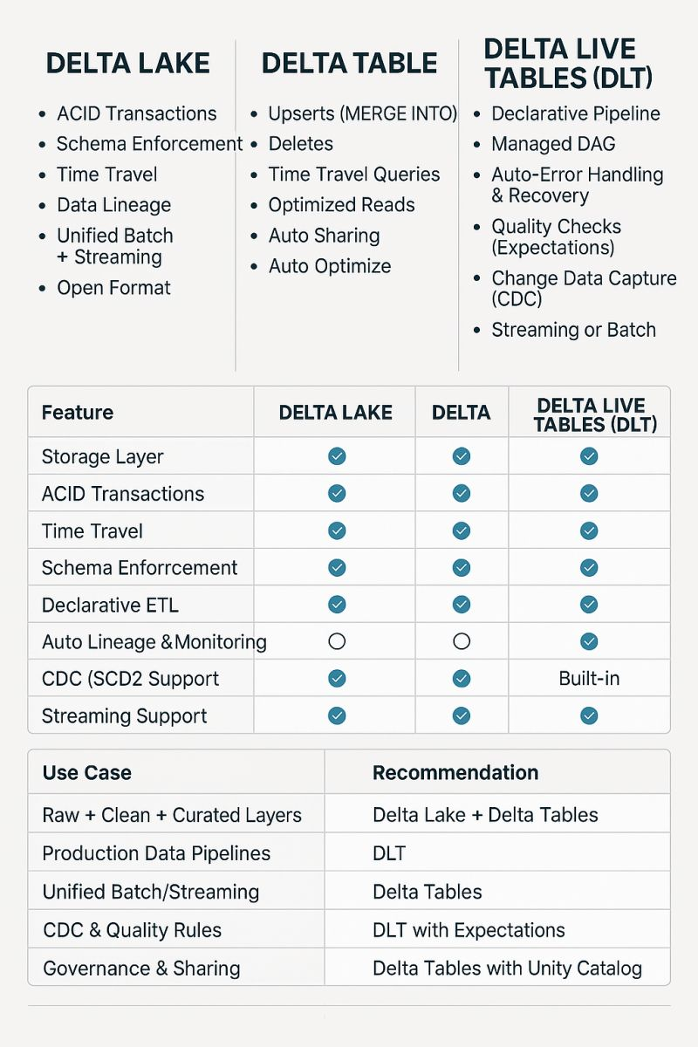

UNITY CATOLOGS

The core components of Databricks Unity Catalog include:

* **Metastore**: A storage layer for metadata that simplifies data discovery and improves data lineage.
* **Catalog**: A central repository for storing, managing, and discovering data assets.
* **Schema**: A data model used to organize and manage data assets in Databricks Unity Catalog.
* **Granularity**: The level of detail available in metadata tracking. It allows teams to manage access at various levels (catalog, schema, table, or even column), ensuring fine-grained control over data assets.".
* **Tables, views, and volumes**: These are the fundamental data objects in Databricks Unity Catalog used to represent structured and unstructured data.
* [**Data lineage**](https://www.datacamp.com/blog/data-lineage): A visual representation of the flow of data from its source to its destination, helping track changes and ensure data integrity.

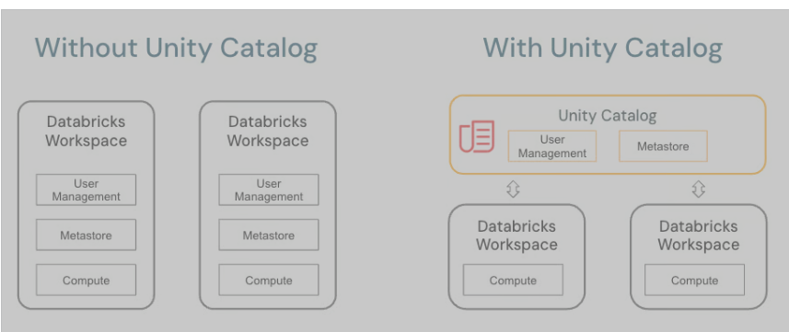

The architecture of Unity Catalog includes three main components:

1. **Metadata Store**: This component stores all the metadata related to datasets, tables, external locations, and other objects.
2. **Catalog**: This component acts as an interface between the Metadata Store and the compute layer. It provides a unified view of all the metadata stored in the Metadata Store, making it easy for users to access and query their data.
3. **Workspaces**: Workspaces are virtual storage locations where data can be securely stored and managed. They allow for easy collaboration between teams by providing a central location for data access and manipulation.